**Network configuration and testing report**  
**project title:** basic LAN communication simulation  
**file name:** XZ Network .PKT  
**prepared by:** [Melvin Baird]  
**date:** [29/7/2025]

**1. Objective**

The objective of this simulation was to configure a simple local area network (LAN) using cisco packet tracer, assign appropriate IP addresses, and verify network connectivity between a pc and a server using the protocol (ping command).

**2. Network topology overview**

The network topology consists of two end devices:

A personal computer (new name pc)

A server (new name server)

These devices are connected via a network switch or directly using a crossover cable (depending on your setup in the packet tracer file).

**3. Ip addressing scheme**

| **Device** | **Ip address** | **Subnet mask** |
| --- | --- | --- |
| New name pc | 192.168.0.1 | 255.255.255.0 |
|  |  |  |
| New name server | 192.168.0.2 | 255.255.255.0 |
|  |  |  |

Both devices are on the same subnet: 192.168.0.0/24.

**Ping result summary:**

**Packets sent:** 4

**Packets received:** 4

**Packet loss:** 0%

**Round-trip time (rtt):**

Minimum = 1ms

Maximum = 6m

Average = 1ms

**Interpretation:**  
the successful transmission and reception of all 4 icmp echo request packets with 0% packet loss confirm that the network is correctly configured and fully operational. The average latency of 1ms indicates very fast local communication, typical in a correctly set-up LAN environment.

**5. Conclusion**

The basic network setup using cisco packet tracer was successfully implemented. The static ip addressing was properly assigned, and communication between the pc and server was confirmed using the ping utility. The test results indicate a stable and responsive network connection with no configuration errors or physical connectivity issues.

**6. Recommendations (optional)**

To expand this project further: Introduce a DHCP server for dynamic ip address assignment.

Add a router to connect to external networks. Configure services on the server (http, ftp, dns).

Implement and security rules for segmentation and control.

c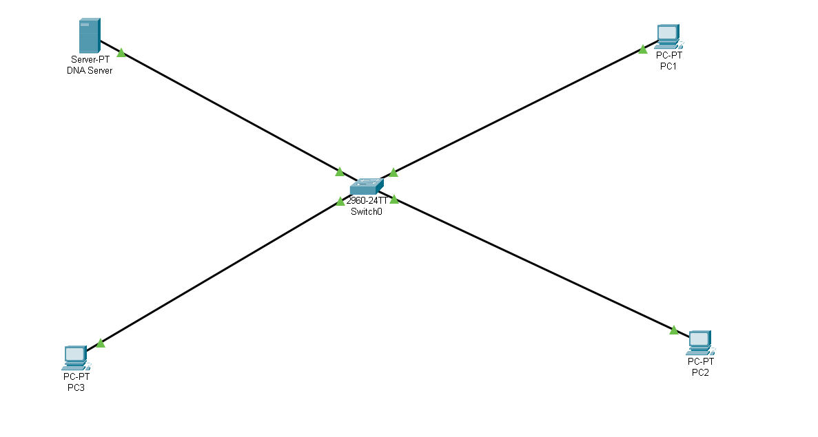

Top of Form

Bottom of Form